**Christopher King**

**2018141521058**

**Mechanical Design 1**

**Class Section 01**

**09/28/2020**

**Problem 1**

**Solution:**

For this question, we are asked to find the shaft diameter needed to transmit when (a) the shaft speed is (b) the shaft speed is .

For the shaft speed is ,

For the shaft speed is ,

**Problem 2**

**Solution:**

1. For this question, we are asked to determine the tensions in the belt on pulley , assuming the shaft is running at a constant speed.

Therefore, I can know that

1. For this question, we are asked to find the magnitudes of the bearing reaction forces.

Solving equation above yields that

Solving equation above yields that

1. For this question, we are asked to draw shear-force and bending-moment diagrams for the shaft. If needed, make one set for the horizontal plane and another set for the vertical plane.

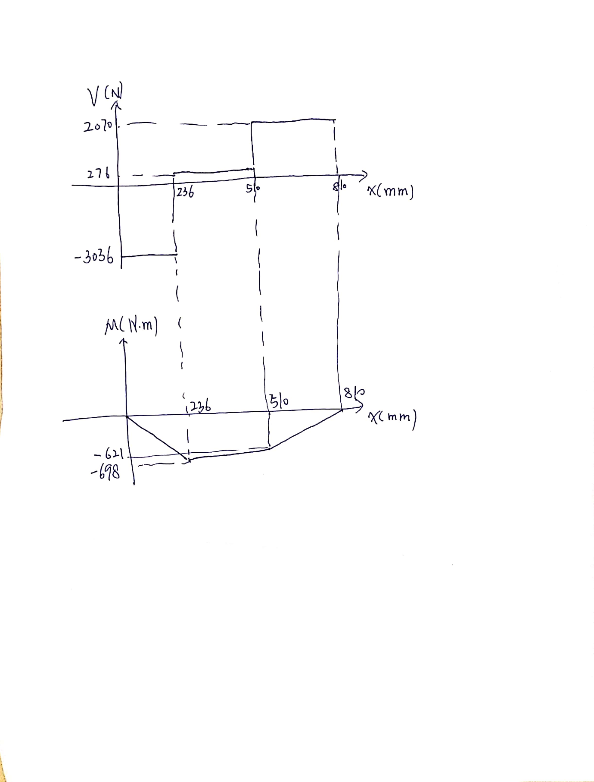

1. For this question, we are asked to determine the bending stress and the torsional shear stress.
2. For this question, we are asked to determine the principal stresses and the maximum shear stress.

Ignore the calculation below, I just use it to check.

The Mohr circle is shown in figure below:

**Problem 3**

**Solution:**

For this question, we are asked to determine the plate thickness.



Since the load acts in a plane of symmetry, there are three independent equations of equilibrium. The internal forces at the section are found using the equations of equilibrium as follows:

Therefore, I can know that

Solving the equation above yields that